# Assignment 1

# In total 100 points

# Q1 (10 pts):

It’s only correlation not causal (4 pts). Reasons: these two could both increase when temperature goes up (6 points） for mentioning that these two can be both driven by temp./summer).

# Q2 (10 pts):

(2 pts for each)

1. Positive
2. Positive
3. Normative
4. Positive
5. Normative

# Q3：

What is the opportunity cost of going to Disneyland?

# A:

The opportunity cost of going to Disneyland movie includes the monetary cost of admission plus the time cost of taking subway and playing for several hours (4 pts).

Benefits (2pts)

The time cost depends on what else you might do with that time; if it's staying home and watching TV, the time cost may be small, but if it's working an extra three hours at your job, the time cost is the money you could have earned.(4pts)

# Q4:

The market for pizza in HKUST has the following demand and supply schedules:

Price Quantity Demanded Quantity Supplied

# Graph (3 pts)

Quantity supplied equals quantity demanded at a price of $6 and quantity of 91 keyboards.(3pts)

If price were greater than $6, quantity supplied would exceed quantity demanded, so suppliers would reduce their price to gain sales (4pts).

If price were less than $6, quantity demanded would exceed quantity supplied, so suppliers could raise their price without losing sales (4pts). In both cases, the price would continue to adjust until it reached $6, the only price at which there is neither a surplus nor a shortage.

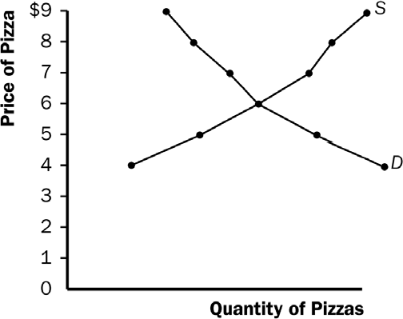

# A：

If the price ceiling of $40 per ticket is below the equilibrium price, then quantity demanded exceeds quantity supplied, so there will be a shortage of tickets. The policy decreases the number of people who attend classical music concerts, since the quantity supplied is lower because of the lower price.

Also mention that if the price ceiling is not binding, then no impact.

# Q5：

Suppose the HK government requires beer drinkers to pay a $2 tax on each case of beer purchased. (In fact, all the governments around the world impose beer taxes of some sort.)

1. Figure 4 shows the market for beer without the tax (graph for 2pts). The equilibrium price is *P*1 and the equilibrium quantity is *Q*1 (3 pts). The price paid by consumers is the same as the price received by producers. (3pts)

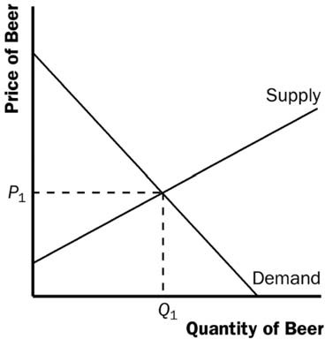

# Figure 4

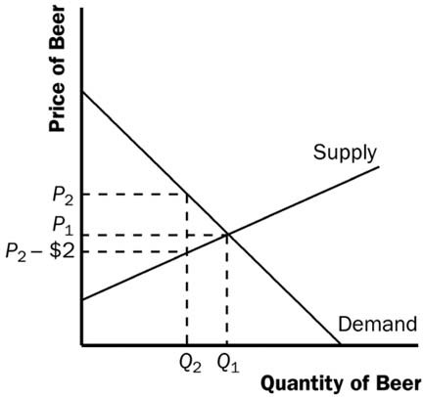

or: 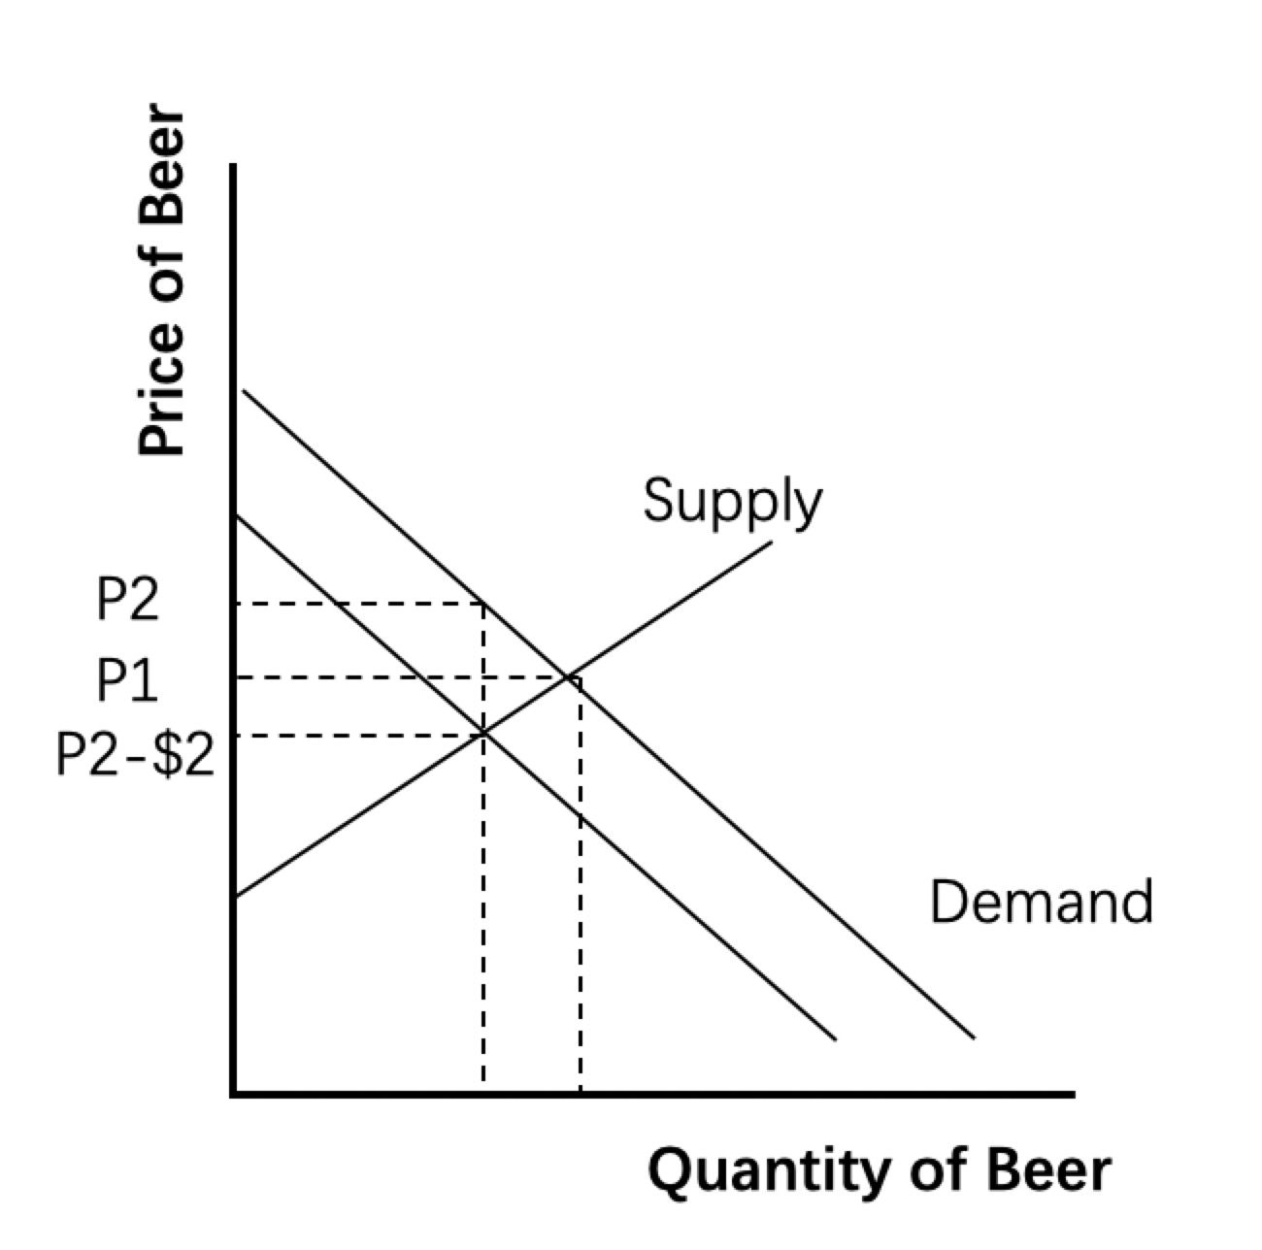

**Figure 5**

1. When the tax is imposed, it drives a wedge of $2 between supply and demand, as shown in Figure 5 (3 pts). The price paid by consumers is *P*2, while the price received by producers is *P*2 – $2. The quantity of beer sold declines to *Q*2.(3 pts), Difference between the price paid by consumers and the price received by producer(3pts)， Consumption will be reduced (2pts)

# Q6：

The government uses two programs that affect the market for Chinese liquor (“Baijiu”). Media campaigns and labeling requirements are aimed at making the public aware of the dangers of drinking alcohol. At the same time, the Department of Agriculture maintains a price support program for grains (primary inputs of “Baijiu”), which raises the price of grains above the equilibrium price.

1. How do these two programs affect alcohol consumption (3pts)? Use a graph of the Chinese liquor market in your answer (3pts).
2. What is the combined effect of these two programs on the price of “Baijiu” (4 pts)?
3. The Chinese liquors are also heavily taxed. What effect does this tax have on consumption?(4pts)

# A；

1. As a result of media campaigns, awareness among consumers will grow and demand for Baijiu will drop. At the same time, supply drops too because of the rising price of grains. The equilibrium shifts from E1 to E2. The quantity changes from Q1 to a lower Q2. Therefore, Alcohol consumption will decrease.

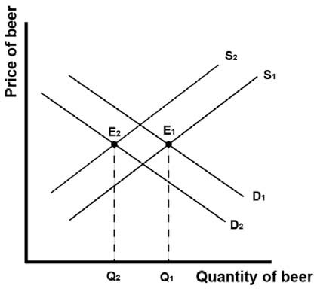

1. The effect on price, however, is unclear and depends on both the demand and supply curves. It can either rise, decrease or remain the same.
2. A tax results in a decrease in demand, which in turn results in a lower price and lower quantity. A lower quantity means a lower consumption.

# Q7:

# Incentive (5 pts)

# Reasons (7 pts)

# Q8:

Making condoms widely available is considered to be an important tool of HIV prevention. To reduce HIV, the government can distribute free condoms in communities with high HIV prevalence. What would be the consequences of this program?(5pts) How do you think people will respond to it and what its impact on HIV transmission?(7pts)

# A:

Risk compensation is a theory which suggests that people typically adjust their behavior in response to the perceived level of risk, becoming more careful where they sense greater risk and less careful if they feel more protected. Although usually small in comparison to the fundamental benefits of safety interventions, it may result in a lower net benefit than expected.

Making condoms free would make the demand rise dramatically. As a result, people would go to get condoms and use them more. As a result, HIV transmission will be harmed. As condoms become free, people will get condoms and use more. This is the direct incentive. This will reduce HIV transmission. However, there is also a different incentive. As it gets safer using condoms, people might engage in more risky sexual behaviours and find more sexual partners. This incentive is very similar to our discussion on seat belt law. This will raise HIV transmission.